Standardized Terminology

What is Standardized Terminology
# Source: Chatgpt (GPT-4-turbo) at [7/31/2025]
Standardized terminology refers to a set of officially agreed-upon terms that are defined, regulated, and maintained by recognized authorities or professional organizations to ensure uniform understanding and usage across fields.

✅ Key Features:
# Source: Chatgpt (GPT-4-turbo) at [7/31/2025]
- Regulated by institutions (e.g., ISO, WHO, IEEE, ASTM, legal or governmental bodies)
- Terms have precise, unambiguous definitions
- Essential for technical accuracy, legal clarity, and interoperability
- Frequently updated to reflect new knowledge or standards

📚 Examples:
# Source: Chatgpt (GPT-4-turbo) at [7/31/2025]
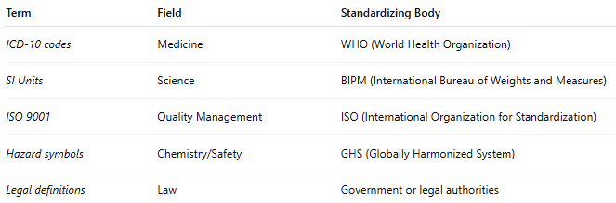
Term | Field | Standardizing Body
ICD-10 codes | Medicine | WHO (World Health Organization)
SI Units | Science | BIPM (International Bureau of Weights and Measures)
ISO 9001 | Quality Management | ISO (International Organization for Standardization)
Hazard symbols | Chemistry/Safety | GHS (Globally Harmonized System)
Legal definitions | Law | Government or legal authorities

👥 Primary Users:
# Source: Chatgpt (GPT-4-turbo) at [7/31/2025]
- Professionals in medicine, law, science, and engineering
- Technical communicators and translators
- Standards developers and policy makers

